Bound Function

* Context and/or arguments are bound to specific values
* .bind() method
* Original and bound function share the same code and scope, but different contexts and arguments on execution

myFunc.bind(thisArg, arg1, arg2…)

* First argument (thisArg)
  + Context
* Remaining arguments
  + Arguments to bound to
* Returns a NEW FUNCTION which context is bound to thisArg and arguments to arg1, arg2 …

Sample code:

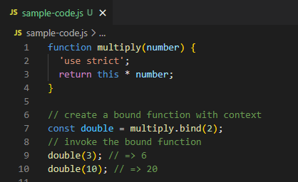

Difference from .apply() and .call()

* .bind() only returns a new function to be stored and invoked LATER
* .apply() and .call() immediately invoke a function